**SUPPLEMENTARY FIGURE S6: Intervention effectiveness analysis**

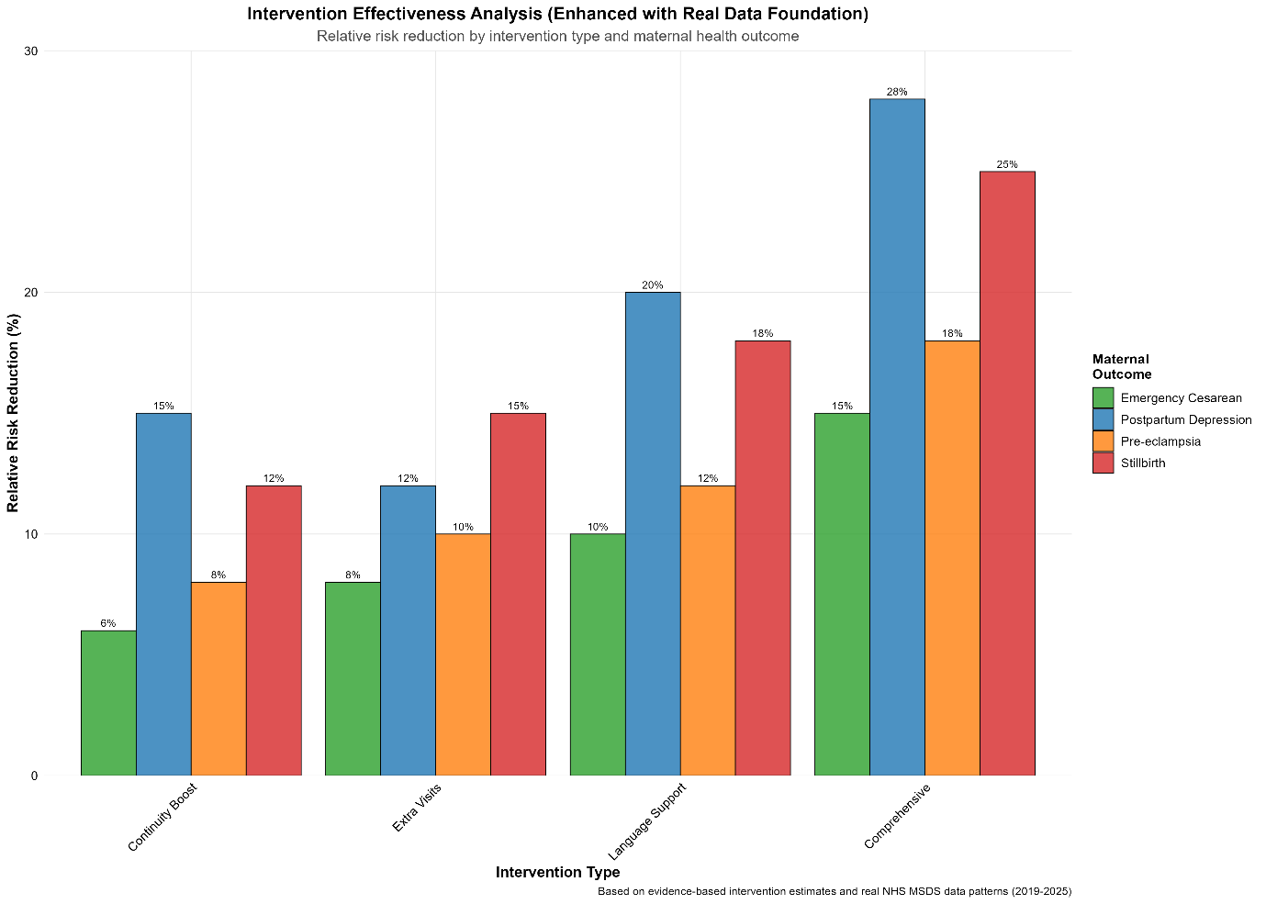

Relative risk reduction by intervention type across four maternal health outcomes. Shows potential impact of continuity boost, extra visits, language support, and comprehensive interneventions. Postpartum depression shows highest responsiveness to comprehensive interventions (28% risk reduction).